Kirin Harrington

Kirin@twosmallpeople.co.uk

NCFE Unit 3

Kelham Island VR project

Contents

LO1 1

Project plan 1

Folder structure 2

File types 3

Documentation 3

3d models 3

Audio files 4

Hardware and software 4

Computer software 4

Photoshop 4

Software requirements 4

Blender 5

Software requirements 5

unity 6

Software requirements 6

Accessibility requirements 6

Asset creation 7

Title 7

3D models 7

Enviroment 7

Exhibits 7

Product creation 7

Unity project 7

# LO1

## Folder structure

Having a good and consistent file structure is very important as it makes the creation of a product a lot easier, it allows you to be able to find your work very easily and allows you to back up work easily, so you don’t lose anything. If you do not have a good folder structure it can be easy to lose track of where files are, and you can lose a lot of time attempting to find files.

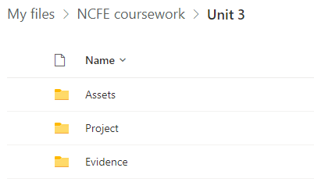

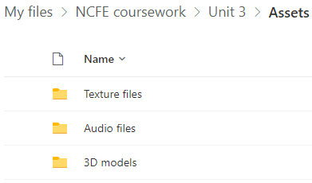

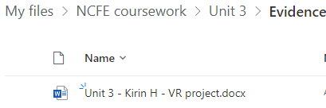

## File types

### Documentation

For the documentation I will make about my interactive media project I will be using word documents with the .docx format, this is because word was installed on the school PC’s so it is readily available, it is also widely supported so will be extremely useful.

### 3d models

For the 3D models that I will have to create I will be using the .blend file format. This is because it is automatically used in Blender, the software I will be using to create 3d models.

### Audio files

For audio files I will be using the .MP4 file format as it is extremely popular and will work with basically any audio editing software.

## Hardware and software

### Computer software

I used the school computers because they were readily available and consistent, meaning I knew what software they would have and how fast they would run, there were also an abundance of them meaning there was always a machine available. However, they are not the most up-to-date machines so don’t run the fastest, the school has also installed software on them that isn’t required for this qualification which will have taken up storage space unnecessarily and slowed them down.

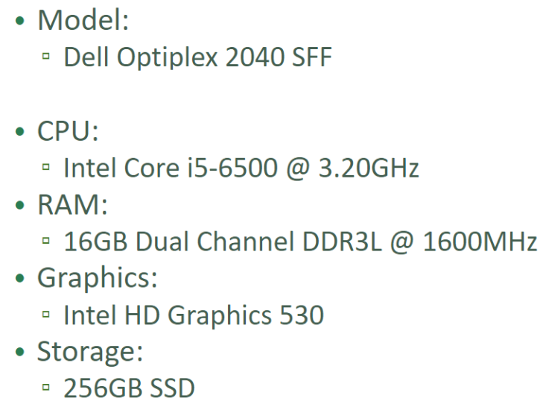

### Photoshop

To edit images, I will be using photoshop, as it is installed on the school computers, and is therefore very convenient, it is also considered to be one of the best pieces of software for image editing.

#### Software requirements

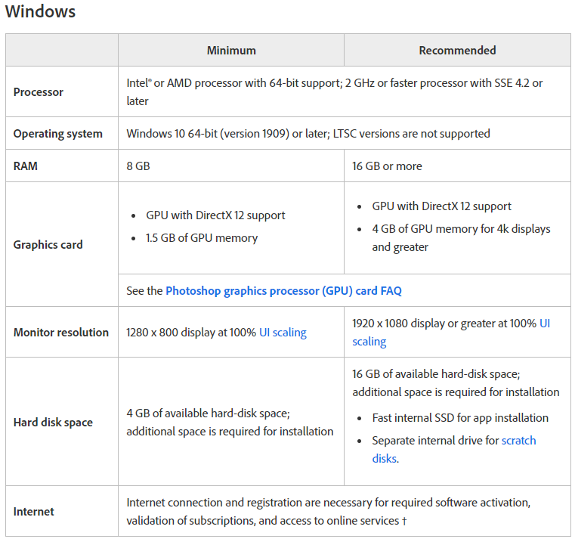

The school computers fit all of the recommended criteria apart from hard disk space, which they are running quite low on due to the number of other programs installed, because of this, photoshop should run quite well, with barely any problems.

### Blender

I will use Blender to create 3d models for my interactive media project, I am quite familiar with this software so it will be reasonably

#### Software requirements

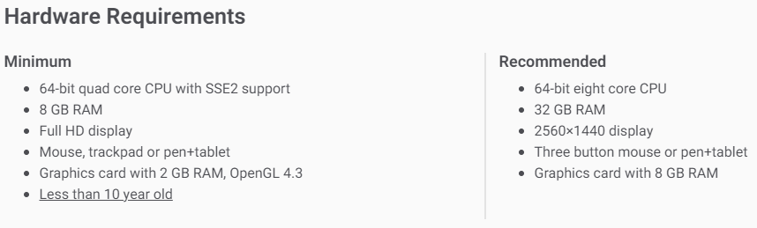

The computers available at school are well over the requirements blender recommends, and it should therefore run without problems, at a very fast speed, because of this blender is a very good piece of software to use.

### unity

I will be using Unity for the bulk of my project, as it is the software, I will be using to create my interactive media project, it is where I will combine all the assets I have created in other pieces of software and create the full experience.

#### Software requirements

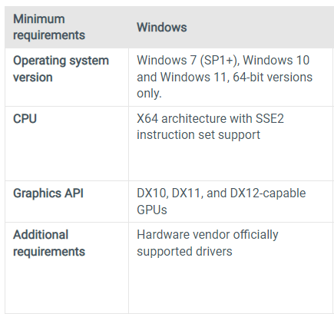

Unity appears to not have many software requirements and therefor it should run very well, it is also compatible with the oculus quest, which I am intending to use for my interactive media project.

## Accessibility requirements

I will need to make sure that the project I create is as accessible as it can be, to accomplish this I will incorporate options to change the font size and the colour of the text, I will also incorporate videos and images for younger audiences.

# LO2

## Project plan

Having a time plan is essential because it can break down a very large and overwhelming project into more manageable chunks. Having a time plan also helps you make sure that you are on track to complete your project. It makes sure you know what goals you need to complete.

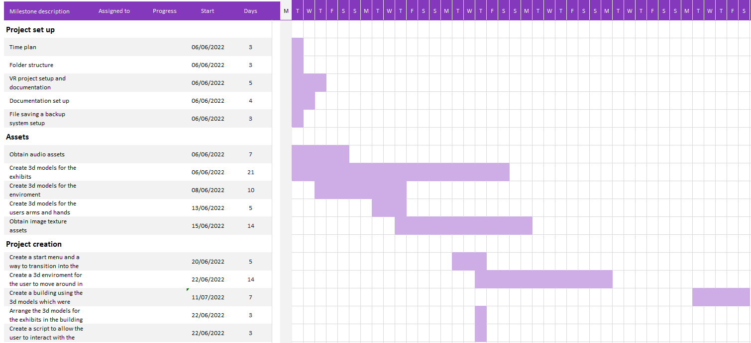

## Asset creation